**Diagnostic Analytics Use cases**

**Use Case 1: Addressing Runtime Deviation in Robotic Assembly Lines**

**Company:** **Toyota Motor Corporation**

**Problem:** Toyota noticed that the average runtime of their robotic assembly lines in their Texas plant began to deviate significantly, leading to production slowdowns and inefficiencies.

**Description:**

Toyota’s robotic assembly lines experienced longer-than-expected runtimes due to inconsistencies in the calibration of robotic arms, resulting in a 15% decrease in production efficiency and 20% decrease in product quality.

**Detailed Problem Statements:**

1. **Inconsistent Calibration:** The robotic arms were not calibrated correctly, leading to inefficient operation.

**Whys:**

* Calibration processes were not standardized.
* Operators lacked detailed training on calibration procedures.
* Calibration equipment was outdated and provided inaccurate readings.

1. **Wear and Tear:** Mechanical wear in the robotic arm joints caused variations in movement speed.

**Whys:**

* Regular wear and tear were not addressed in a timely manner.
* Maintenance schedules were not followed rigorously.
* The budget allocation for replacement parts was insufficient.

1. **Inadequate Maintenance:** Routine maintenance was not conducted at the necessary intervals, allowing issues to accumulate.

**Whys:**

* Maintenance procedures were based on reactive rather than preventive measures.
* There was a lack of real-time monitoring tools to detect issues early.
* Resource constraints limit the maintenance team's capacity.

1. **Machine Overheating:** Increased Downtime in Manufacturing Due to Machine Overheating

**Whys:**

* Poor Ventilation on the **m**anufacturing floor layout does not allow for adequate cooling of machinery.
* Overworked Machines were running beyond their capacity without breaks, leading to overheating.
* Lack of Predictive Maintenance in the system to predict when machines are likely to overheat.

**Action Items:**

* Implement a standardized calibration process and provide detailed training to operators.
* Upgrade calibration equipment to ensure accurate readings.
* Follow a preventive maintenance schedule with proper resource allocation.
* Install real-time monitoring tools to detect potential mechanical wear.
* Adjust production schedules to include buffers for unexpected downtime.

**Solutions:**

1. **Inconsistent Calibration:**

* Provide comprehensive training for operators on the updated calibration procedures, focusing on both the technical aspects and the importance of regular calibration.
* Invest in modern, high-precision calibration tools that provide accurate readings, reducing the likelihood of calibration errors.

1. **Wear and Tear:**

* Establish a proactive maintenance schedule that specifically addresses regular wear and tear of robotic arm joints, preventing variations in movement speed.
* Allocate sufficient budget for the timely replacement of worn-out parts, ensuring that all robotic arms operate at optimal efficiency.

1. **Inadequate Maintenance:**

* Transition from a reactive to a preventive maintenance strategy, focusing on regular, scheduled maintenance to prevent issues from accumulating.
* Integrate real-time monitoring systems that can detect potential issues early, allowing the maintenance team to address them before they occur.

1. **Machine Overheating:**

* **Improve Ventilation on Manufacturing Floor:** Redesign the manufacturing floor layout to enhance ventilation, ensuring that machines have adequate cooling to prevent overheating.
* **Optimize Machine Usage:** Implement operational protocols that prevent machines from being overworked by scheduling regular breaks, reducing the risk of overheating.

**Outcomes:**

* Production efficiency increased by 20%.
* Overtime costs were reduced by 30% due to fewer production delays.
* Improved predictability in production schedules led to better overall planning.
* Maintenance schedules were updated to include more frequent checks on robotic arm calibration and joint integrity.
* Enhance product quality and reduce reject rates.
* Machine operational cost savings by reducing material waste.

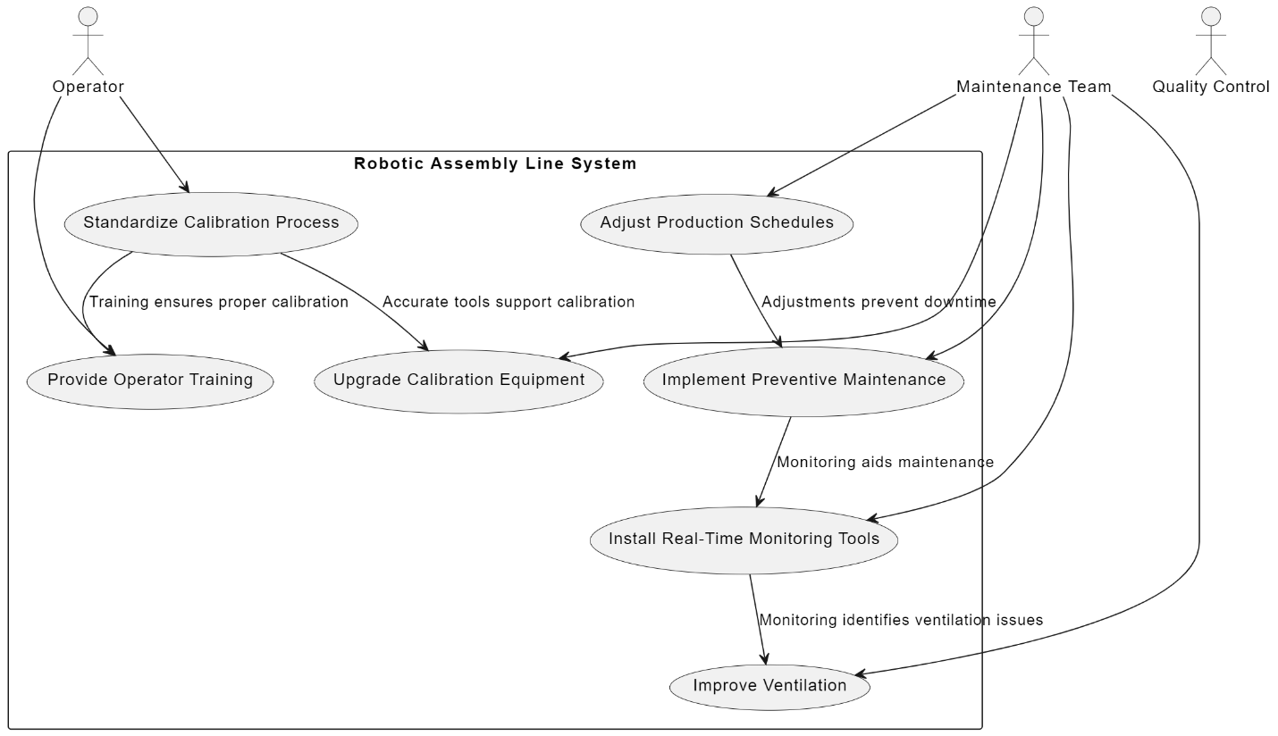

**Use Case 2: Optimizing Runtime Deviation in Plastic Injection Molding Machines**

**Company:** **Procter & Gamble (P&G)**

**Problem:** P&G identified a runtime deviation in their plastic injection molding machines in their Cincinnati facility, which led to irregular product quality and increased material waste.

**Description:**

The average runtime of P&G’s plastic injection molding machines started to deviate, leading to uneven cooling times for the molded products, which caused defects in the final consumer goods.

**Detailed Problem Statements:**

1. **Coolant Temperature Fluctuations:** Unstable power supply caused fluctuations in coolant temperature, leading to inconsistent runtime.

**Whys:**

* The power supply was unstable, leading to temperature variations.
* Cooling systems were outdated and lacked proper control mechanisms.
* Regular checks on the cooling system were not performed.

1. **Aging Injection Molding Machines:** The machines used were old and had parts that were worn out.

**Whys:**

* The machines were old and not replaced despite frequent breakdowns.
* Capital expenditures were deferred to focus on short-term savings.
* Maintenance costs were high, leading to budget cuts in other areas.

1. **Insufficient Monitoring:** Lack of real-time monitoring to detect issues early on.

**Whys:**

* There was no real-time monitoring of machine performance.
* The existing monitoring system was manual and prone to errors.
* Investment in advanced monitoring technology was delayed.

**Action Items:**

* Stabilize the power supply and upgrade the cooling system to prevent temperature fluctuations.
* Replace aging machines with newer models to reduce the frequency of breakdowns.
* Implement a real-time monitoring system to detect issues early.
* Conduct frequent inspections to catch defects during the production process.
* Establish a waste reduction initiative to minimize material losses.

**Solutions:**

1. **Coolant Temperature Fluctuations:**

* Implement a more stable power supply system to eliminate fluctuations and ensure consistent coolant temperature.
* Replace outdated cooling systems with advanced models that have built-in control mechanisms to maintain optimal temperature levels.

1. **Aging Injection Molding Machines:**

* Invest in new injection molding machines to replace old, worn-out equipment, reducing breakdowns and improving efficiency.
* Shift focus from short-term savings to long-term investment in machinery and equipment to avoid frequent repairs and production downtime.

1. **Insufficient Monitoring:**

* Introduce a real-time monitoring system to continuously track machine performance and detect issues early.
* Replace manual monitoring systems with automated solutions to reduce errors and improve accuracy in data collection.

**Outcomes:**

* Product defects decreased by 25% and material waste was reduced by 40%.
* Overall operational efficiency improved due to fewer machine breakdowns.
* Enhance product quality and reduce reject rates.

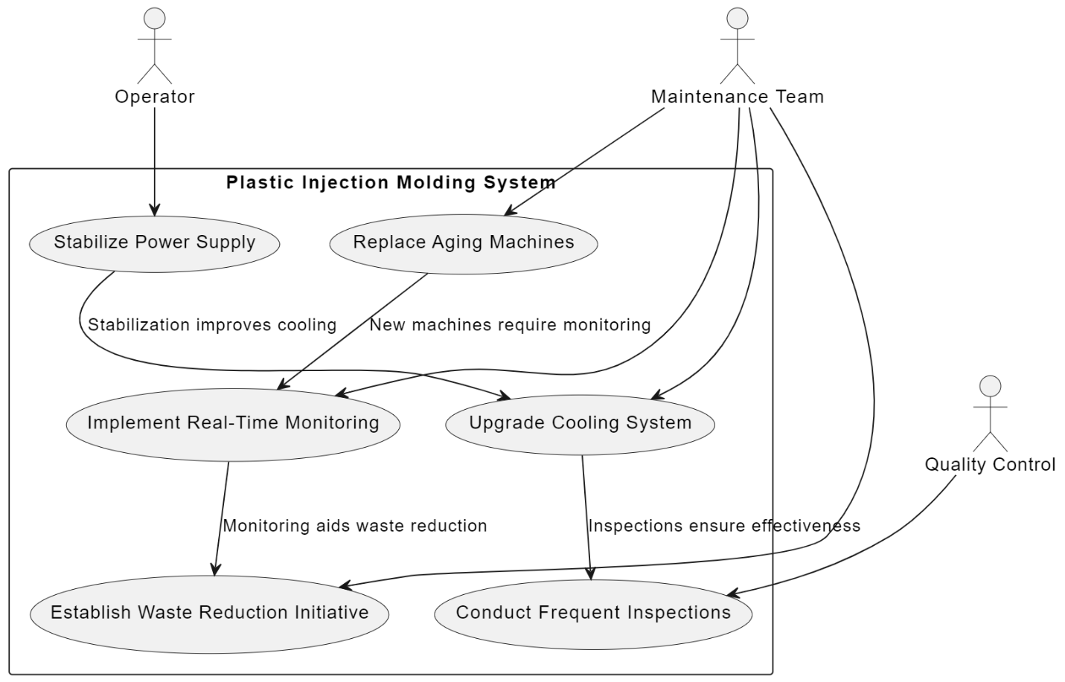

**Use Case 3: Resolving Runtime Deviation in Textile Weaving Machines**

**Company:** **Hanesbrands Inc.**

**Problem:** Hanesbrands observed that the average runtime of their textile weaving machines at their North Carolina plant was deviating, causing delays in fabric production and leading to bottlenecks in the supply chain.

**Description:**

Hanesbrands’ textile weaving machines began to show variations in runtime, which resulted in delays in fabric production and inconsistencies in the weave quality, leading to increased rejects.

**Detailed Problem Statements:**

1. **Worn Tension Control Systems:** The tension control systems in the weaving machines were worn out, causing runtime deviations.

**Whys:**

* The tension control systems were not replaced after the recommended lifespan.
* Budget constraints led to delayed replacement.
* Maintenance focused on reactive rather than preventive measures.

1. **Inconsistent Quality Checks:** Quality checks were not frequent enough to catch the issue early.

**Whys:**

* Quality checks were infrequent, and inconsistencies were often missed.
* There was no real-time quality monitoring system.
* Quality assurance relied heavily on manual inspections.

1. **Delayed Maintenance:** Maintenance was delayed, allowing the problem to escalate.

**Whys:**

* Maintenance was delayed due to insufficient staffing.
* Maintenance schedules were not strictly adhered to.
* There was a lack of spare parts for immediate repairs.

1. **Misalignment of Packaging Equipment:** Packaging machines were not properly aligned, causing variations in runtime.

**Whys:**

* Alignment checks were not included in the regular maintenance schedule.
* Operators were not adequately trained to detect and correct misalignment issues.
* The necessary tools and equipment for precise alignment were not available on-site.

**Action Items:**

* Replace worn tension control systems and adhere to recommended replacement schedules.
* Strengthen the maintenance team and ensure strict adherence to maintenance schedules.
* Implement a real-time quality monitoring system to detect fabric inconsistencies early.
* Adjust production scheduling to allow for flexibility in case of machine issues.
* Enhance quality control measures to reduce reject rates.

**Solutions:**

1. **Worn Tension Control Systems:**

* **Replace outdated tension control systems**: Implement a policy to replace tension control systems after their recommended lifespan, ensuring that all machinery operates efficiently.
* Allocate funds specifically for the timely replacement of critical machine components, preventing budget constraints from delaying necessary repairs.

1. **Inconsistent Quality Checks:**

* Establish a more frequent schedule for quality checks to ensure that any deviations in machine performance or product quality are identified and addressed promptly.
* Incorporate automated systems to enhance the accuracy and consistency of quality checks, minimizing human error and improving overall product quality.

1. **Delayed Maintenance:**

* **Adhere strictly to maintenance schedules**: Enforce adherence to maintenance schedules, using automated reminders and checklists to ensure that no maintenance tasks are overlooked.
* **Maintain an inventory of critical spare parts**: Create a dedicated inventory of spare parts for immediate repairs, reducing downtime caused by waiting for parts to be delivered.

1. **Misalignment of Packaging Equipment:**

* **Include alignment checks in routine maintenance**: Incorporate alignment checks into the regular maintenance schedule to ensure that packaging machines are properly aligned and operating efficiently.
* **Enhance operator training**: Provide comprehensive training for operators to identify and correct misalignment issues, empowering them to maintain optimal machine performance.

**Outcomes:**

* Significant reduction in fabric inconsistencies, improving product quality.
* Production delays reduced by 25% resulted in improved overall efficiency.
* The reject rate was reduced by 30%.
* Maintenance protocols were updated to include regular tension control inspections.

